Discussion Assignment Unit 7
1. Explain the concept of isomorphism in discrete mathematics.
The concept of isomorphism refers to a relationship between two graphs where they are essentially the same in structure, although the names of their vertices may differ (Levin, 2021). Generally, two graphs are considered isomorphic if there exists a bijection, called an isomorphism, between their vertices such that the edges between vertices in one graph correspond to edges between the corresponding vertices in the other graph (Levin, 2021). Therefore, an isomorphism between two graphs preserves the connectivity pattern between vertices while allowing for a renaming of the vertices.
2. Answer the following for the above two graphs.
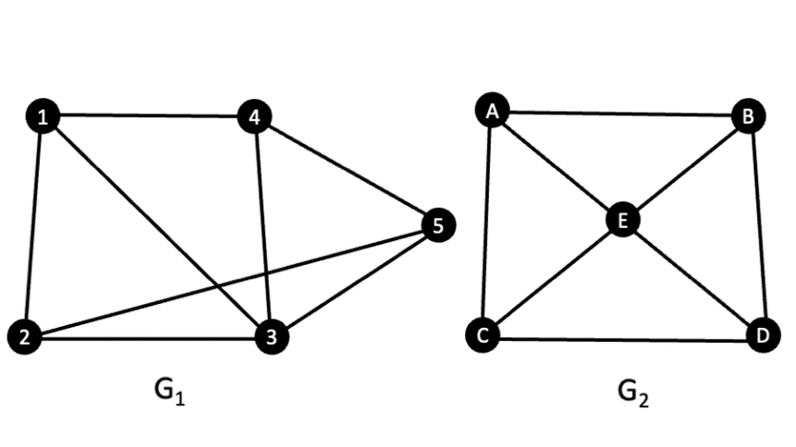
a. Explain in detail how you check isomorphism for the two graphs.
For $G_{1}=\left(V_{1},E_{1}\right)$:
$$V_{1}=\left\{1,2,3,4,5\right\}, E_{1}=\left\{\left\{1,2\right\},\left\{2,3\right\},\left\{2,5\right\},\left\{1,3\right\},\left\{3,4\right\},\left\{3,5\right\},\left\{1,4\right\},\{4,5\}\right\}$$
For $G_{2}=\left(V_{2},E_{2}\right):$
$$V_{2}=\left\{A,B,C,D,E\right\}, E_{2}=\left\{\left\{A,C\right\},\left\{A,E\right\},\left\{A,B\right\},\left\{B,E\right\},\left\{B,D\right\},\left\{E,D\right\},\left\{E,C\right\},\{C,D\}\right\}$$
The graphs are NOT equal, since $V_{1}$∉$E_{2}$ and $V_{2}$∉$E_{1}$. However, since both graphs contain the same number of vertices and same number of edges, they might be isomorphic (this is not enough in most cases, but it is a good start).
- 3 in $G_{1}$ is matching E in $G_{2}$ because both are connected to four vertices, hence having the highest degree of four.
- 1 in $G_{1}$ is matching A in $G_{2}$ because are connected to three vertices including vertices 3 and E respectively, which have a degree of four.
- 2 in $G_{1}$ is matching C in $G_{2}$ because are connected to three vertices including vertices 3 and E respectively, which have a degree of four.
- 5 in $G_{1}$ is matching D in $G_{2}$ because are connected to three vertices including vertices 3 and E respectively, which have a degree of four.
- 4 in $G_{1}$ is matching B in $G_{2}$ because are connected to three vertices including vertices 3 and E respectively, which have a degree of four.
Now we need to build the bijection $g:V_{1}→V_{2}$ by defining the corresponding vertices as follows:
$g\left(3\right)=E$, $g\left(1\right)=A$, $g\left(2\right)=C$, $g\left(5\right)=D$, and $g\left(4\right)=B$.
The eight edges in $G_{1}$ are: $\left\{\left\{1,2\right\},\left\{2,3\right\},\left\{2,5\right\},\left\{1,3\right\},\left\{3,4\right\},\left\{3,5\right\},\left\{1,4\right\},\{4,5\}\right\}$
Under proposed isomorphism, they become:

$$\left\{g\left(1\right),g\left(2\right)\right\}=\{A,C\}$$
$$\left\{g\left(2\right),g\left(3\right)\right\}=\{C,E\}$$
$$\left\{g\left(2\right),g\left(5\right)\right\}=\{C,D\}$$
$$\left\{g\left(1\right),g\left(3\right)\right\}=\{A,E\}$$
$$\left\{g\left(3\right),g\left(4\right)\right\}=\{E,B\}$$
$$\left\{g\left(3\right),g\left(5\right)\right\}=\{E,D\}$$
$$\left\{g\left(1\right),g\left(4\right)\right\}=\{A,B\}$$
$$\left\{g\left(4\right),g\left(5\right)\right\}=\{B,D\}$$

Since all the proposed isomorphism above are precisely the edges in $G_{2}$, we can conclude that $g$ is an isomorphism, so $G_{1}≅G_{2}$.
b. Discuss the conditions of isomorphism for the two graphs in detail.
The conditions of isomorphism for the two graphs involve establishing a bijection $g:V_{2}​→V_{2}​$ between their vertices that preserves the edge relation. Here's a detailed discussion of these conditions:
- Same Number of Vertices and Edges: Initially, we note that both graphs have the same number of vertices and edges. While this is not sufficient to guarantee isomorphism, it's a good starting point.
- Vertex Matching: We need to match vertices between the two graphs based on their degrees and connectivity.
- Building the Bijection: Once the vertex matching is established, we construct the bijection $g:V_{1}→V_{2}$ by defining the corresponding vertices.
- Edge Correspondence: After defining the bijection, we need to ensure that the edges in $G_{1}$​ correspond to edges in $G_{2}$​ under the mapping $g$. We verify that each edge in $G_{1}$​ has a corresponding edge in $G_{2}$ based on the vertices' mappings.
c. Are these two graphs G₁ and G₂ isomorphic?
i. If yes, explain.
Yes, these two graphs $G_{1}$ and $G_{2}$​ are isomorphic. The bijection $g$ established between their vertices preserves the edge relation, as each edge in $G_{1}$ corresponds to an edge in $G_{2}$​ under the mapping $g$.
ii. If you have to try to make them isomorphic then what change do you try first?
If attempting to make them isomorphic, one may first try to identify vertices in one graph that share similar degrees and connectivity patterns with vertices in the other graph. By matching such vertices and verifying if the resulting bijection preserves the edge relation, one can attempt to establish isomorphism.
Reference
Levin, O. (2021). Discrete mathematics: An open introduction (3rd ed.). licensed under CC 4.0

